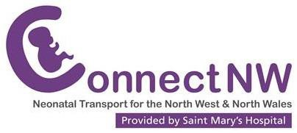
Information for Patients
Travelling in the ambulance with your baby

About Connect North West

Connect North West (Connect NW) is a network service responsible for the transfer of babies between Neonatal Units in Greater Manchester, Lancashire and Cumbria, Cheshire, Merseyside and North Wales. The team has two bases, one in Manchester and one in Liverpool and is made up of doctors, advanced neonatal nurse practitioners (ANNPs) and nurses, all of whom are trained and experienced in transporting babies.

Information about the hospitals we transfer to
Information about the transport team

Travelling with your baby

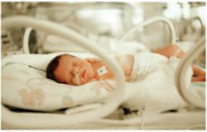
Connect NW offer one parent/carer the opportunity to travel with their baby for out- patient appointments, return journeys to a booking hospital or transfers to hospitals closer to home. The parent travelling with their baby will be asked to read this leaflet and sign the consent form once they are ready for transfer.

Please note that the final decision to transfer your baby, or for a parent to accompany them, will be made by the team transferring your baby.

In the ambulance
Due to seating and space restrictions only one parent may accompany their baby, and only one small piece of luggage may be transferred. You must wear a seatbelt and remain seated in the ambulance at all times.

Departure from the referring hospital
To ensure a timely departure and to avoid delays we would like to request that you are present on the Neonatal Unit with your baby at the time of departure. Unfortunately the team will be unable to wait for late arrivals.

Postnatal mothers
Either parent may travel with their baby. To ensure a mother is fit to travel safely you must be discharged from hospital, medically fit and independently mobile.

Travel sickness
Please be aware that you will be seated in a backwards facing seat. On occasion the ambulance may be required to travel at speed and consequently the journey may feel bumpy, which may cause travel sickness. If you usually suffer from travel sickness you may wish to make alternative travel arrangements.

Your baby’s safety
The transport team’s priority is the safe transfer of your baby. On the day of transfer
the team will assess your baby’s fitness to travel. Very occasionally they may feel it is not safe or appropriate to transfer your baby at this time. Should this happen, you will be given a detailed explanation, and the transfer will be rearranged at a later date. All babies are accompanied by a nurse for their journey, and a doctor or advanced neonatal nurse practitioner (ANNP) when required.

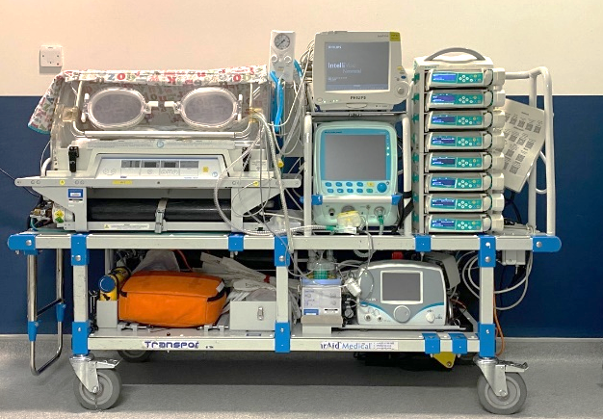
Equipment used during transfer
Prior to departure the transport team will explain any equipment your baby may require. Your baby will travel in a heated transport incubator similar to the one pictured here. The incubator locks securely into the ambulance and soft Velcro straps ensure your baby is safely secured in the incubator.

Monitors and alarms
The transport team will continuously monitor your baby and record readings from the monitor during the transfer. Bumpy roads can cause false alarms on the monitor to trigger, so please be aware that the alarms may go off several times during the journey.

Keeping you informed
The transport team will update you about your baby’s condition prior to the transfer and they will try their best to keep you updated throughout the journey. Please be aware that should your baby need urgent treatment, the team will need to focus solely on your baby and will give explanations later on.
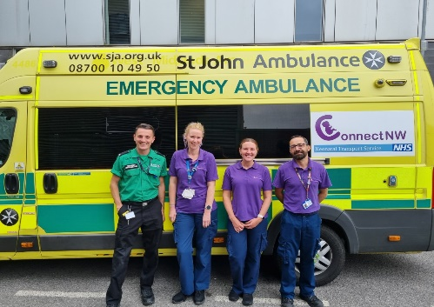

We hope the above information is useful to you.
If you have any other questions prior to our arrival please speak to the nurse caring for your baby, or the transport team on their arrival.

I have received and read the information leaflet ‘Travelling in the Ambulance with Your Baby’, and understand the transport team role and my responsibilities during transfer.

I wish/do not wish to travel with my baby (please delete as appropriate).

Print Name:

Signature:

Date:

